SpecterX On-Premise Deployment Guide



Version 2.2
23.2.2025
support@specterx.com
SpecterX On-Premise Deployment Guide 1
Change Notes for v2.2 3
Introduction 4
Purpose of this Document 4
What is SpecterX 4
Architecture Overview 5
Hybrid On-Premise Architecture 5
Polling - No Incoming Traffic 6
High-Availability 6
Setup Manual 7
Prerequisites 7
Step 1: OVF Image Configuration and Verification 7
Step 2: Configure the static IP address and DNS server 7
Step 3: DNS Configuration in Customer’s Local Server 13
Step 4: Configuration for Kong API Gateway 14
Step 5: WSO2is Configuration & Active Directory Connection 16
Step 6: Storage Connector Service Configuration 24
Step 7: Mail Protection Service (MPS) Configuration 26
Integration With Third-Party Systems 27
Acceptance Tests 28
Scenario 1 - Two-Factor-Authentication 28
Scenario 2 - Supported File Types and Sizes 28
Scenario 3 - Sharing using SpecterX Mail Protection Service 29
Scenario 4 - Data Leak Prevention (DLP) Integration 29
Troubleshooting 30
Going to Production 31
Appendix 1 - LAN Segment Prerequisites 32
3.1. VM Provisioning and Specs 32
3.2. SSL Certificates 35
3.3. Authentication & SSO 36
3.4. Shared storage access 36
3.5. Outgoing mail relay access 36
Appendix 2 - DMZ Segment Prerequisites 38
2.1. VM Provisioning and Specs 38
2.2. SSL Certificates 40
Appendix 3 - Useful Docker Commands 41
Appendix 4 - Kong YAML File Example 45

Change Notes for v2.2
- Added “Appendix 3 - Useful Docker Commands”.
- Updated “Step 2: Configure the static IP address and DNS server” with more details and CLI commands.
- Updated “Step 4: Configuration for Kong API Gateway”.
- Updated texting in some “Sanity Tests” sections.
- Added troubleshooting notes about WSO

Change Notes for v2.3
- Simplified and improved steps in “Configure the static IP address and DNS server” to be easier to run and less error-prone.

Introduction

Purpose of this Document
This guide provides a comprehensive walkthrough for deploying the SpecterX Gateway within a hybrid architecture. It ensures seamless integration between your On-Premise infrastructure and SpecterX Cloud Services to deliver a fully functional SpecterX product.

What is SpecterX
Collaboration is a significant part of any business process, from working with partners and suppliers to managing customers and board communications. Cloud transformation enables and simplifies this. However, while organizations are moving forward to increase productivity, data owners and security teams are concerned with the safety of their digital supply chain, exposing the company’s data and sensitive IP to significant security, privacy, and regulatory risks.
SpecterX allows you to decide how to manage your organizational data. SpecterX knows data can transform your business, drive your innovation, and improve your competitive edge. That’s why we aim to maximize your control over your data in a seamless, secure, and productive manner, helping you meet your business goals.

Collaborate with external entities without giving away data ownership
SpecterX brings complete visibility, total control, and extensive protection over data downstream across the digital supply chain, using one single platform. SpecterX allows organizations to use their data everywhere while managing and protecting it according to their set of rules and policies.

Architecture Overview

Hybrid On-Premise Architecture
SpecterX Gateway offers a hybrid solution for enterprises with isolated LAN networks. It is our on-premise solution that directly connects with the customer’s internal services—like identity provider, mail channels, and storage systems—while hosting an extension of our cloud capabilities. This design creates a seamless bridge to SpecterX Cloud Services, ensuring that the customer benefits from both the security and control of the isolated LAN and the dynamic scalability of the cloud.

SpecterX Gateway Components
- SpecterX Outlook Add-in - Integrates with Outlook to allow users to mark outgoing emails for protection, apply custom policies, and set recipient permissions.
- Mail Protection Server - Functions as an SMTP server that intercepts emails marked for protection, replacing attachments with secure links and enforcing organizational policies.
- Storage Connector Service - Reads and writes data managed by SpecterX (files, emails, etc) in the designated storage. SpecterX bridges the organizational storage by routing file requests through a single secure gateway that employs polling for external access. That way, no-one accesses the storage except for our Storage Connector service
- API Router (LAN) - Manages internal communication between users and SpecterX services within the LAN.
- API Router (DMZ) - For organizations with a DMZ segment, this router channels inbound/outbound traffic between external networks and the internal LAN.
- Internal IdP (WSO2is) - A lightweight identity provider that integrates with the customer’s existing systems (e.g. Active Directory) to streamline user authentication and access control.

SpecterX Cloud Services Components
- SpecterX Cloud API - Acts as the gateway for cloud-to-on-premise communications, interfacing with the API Router to relay commands and data.
- SpecterX Web App - Serves as the central portal for management and administration, enabling policy configuration, user management, and analytics.
- External Identity Provider - Seamlessly provisions identities for external users on-the-fly, simplifying onboarding for data recipients.
- Twilio SMS and Email Services - Leverages trusted third-party providers to deliver timely email and SMS notifications, enhancing overall communication and alerting.
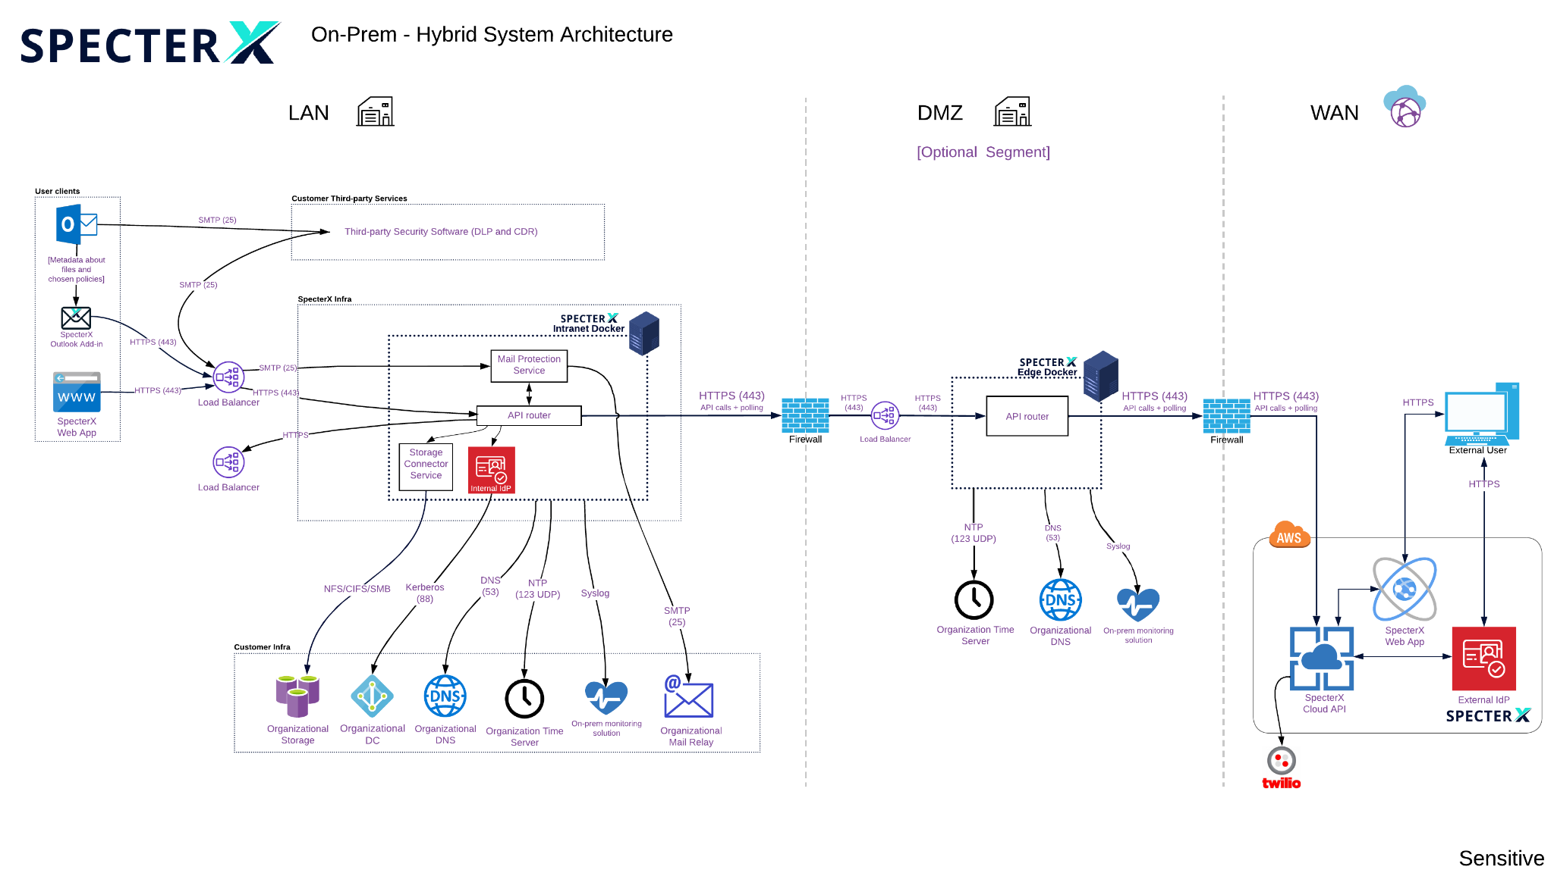

Polling - No Incoming Traffic
SpecterX Gateway employs a polling mechanism within its on-premise architecture. Rather than accepting incoming connections, internal system components actively poll external services for data or update requests. This one-way communication ensures that the internal network remains isolated and secure, effectively preventing unsolicited inbound traffic. By initiating all communications internally, organizations retain strict control over data flow, minimize the risk of unauthorized access, and maintain robust security policies—all while still enabling seamless integration with external entities.

High-Availability
For maximum redundancy and uptime, we recommend deploying two instances of SpecterX Gateway in both your LAN and DMZ. Each pair should be set up behind a load balancer using a Virtual IP (VIP), ensuring seamless failover and balanced traffic distribution. This high-availability configuration minimizes downtime and guarantees continuous service even if one instance encounters issues.

Setup Manual
Each step below is structured with a clear objective, detailed tasks, Sanity Checks (where applicable), and a Definition of Done.

Prerequisites
This manual assumes that all the prerequisites described in the “SpecterX on-prem deployment prerequisites - LAN segment” and “SpecterX on-prem deployment prerequisites - DMZ segment” documents were fulfilled. An overview of the requirements can be found in appendix 1 and 2.

Step 1: OVF Image Configuration and Verification

Objective
Ensure that OVF images are imported and raised appropriately on the customer's ESXi environment, and verify that the hardware configurations match the specified requirements.

Tasks
- Import OVF Images: Import and raise OVF images to the customer's ESXi virtualization platform.
- Configuration Verification:
  - CPU: Ensure it has 4 cores, each with a speed of >=2.2Ghz.
  - RAM: Verify that the allocated RAM is 16 GB.
  - Disk Space: Ensure a total disk space of 80GB is allocated.
  - Network Interface: Confirm a network speed of 1Gbps.

Definition of Done
The OVF image must be up and running on the customer's virtualization server without any issues.

Step 2: Configure the static IP address and DNS server

Objective:
Configure a static IP address for the Linux machine and set up DNS to align with the customer’s DNS servers.

Since the basic network configurations were not defined yet, we can’t SSH into the machine. We need to log in to the servers directly through the VMware Console.

1) Configure the DMZ Server Network

Tasks
- Access the VMware Console: Log in to each of the servers provisioned for SpecterX in the DMZ environment.
- Check Available Network Interfaces: Look for an interface that is not lo (which is the loopback interface). It will typically be named ens32, ens160, or eth0, depending on your system.
To do this, run the following command:

ifconfig -a

Example output from ifconfig -a:

ens32: flags=4163<UP,BROADCAST,RUNNING,MULTICAST> mtu 1500
inet 192.168.1.100 netmask 255.255.255.0 broadcast 192.168.1.255
...
lo: flags=73<UP,LOOPBACK,RUNNING> mtu 65536
inet 127.0.0.1 netmask 255.0.0.0

- For the next steps, we’ll need to switch to a “super user”. This will allow us to edit and save the network configuration files
sudo su
 At this point you will be prompted to enter the
- Open the Netplan configuration file:
nano /etc/netplan/00-installer-config.yaml
- Disable DHCP4 by commenting out or removing the relevant line:
  - Locate the following line:
dhcp4: true
  - Comment it out by adding a # at the beginning:
#dhcp4: true
- Set the static IP address assigned to each DMZ server and define the DNS servers.
  - Refer to Appendix 2 for the correct IP addresses in the DMZ domain.
  - Ensure that the prefix is included (e.g., /24 for a 255.255.255.0 subnet).
- The configuration should look similar to this:
network:
ethernets:
ens32:
#dhcp4: true
addresses:
- 10.253.10.21/24
version: 2
- 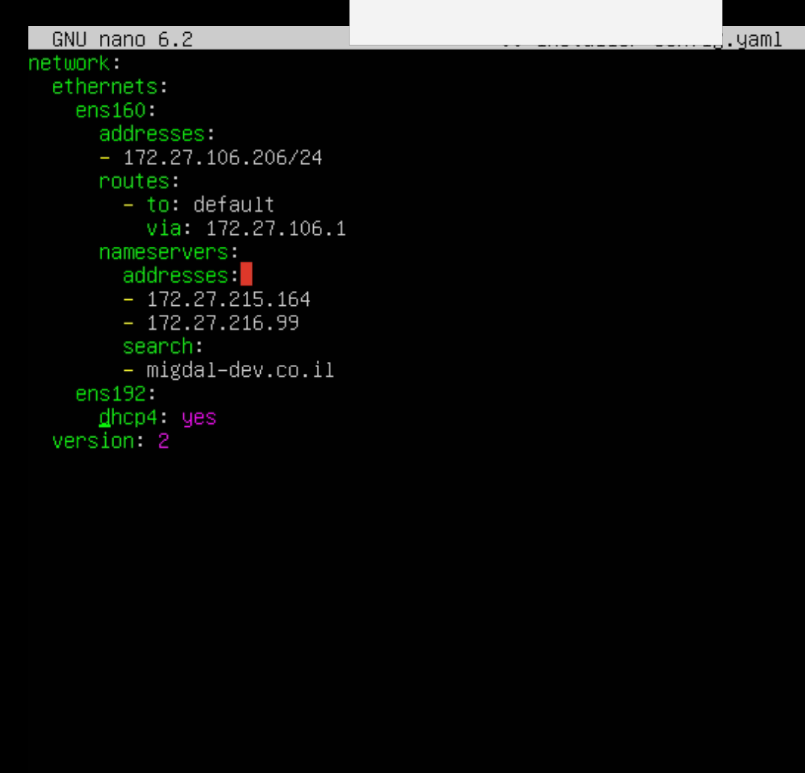
- Save and apply the changes:
  - Save the file in nano by pressing CTRL + X, then Y, and Enter.
  - Apply the new network settings with:
netplan apply
- For Common Issues When Applying Netplan Changes, jump to Troubleshooting for this chapter.
- Verify that the IP address has been updated.

ip a show ens32
* Replace ‘ens32’ with the actual network interface:

Sanity Test
telnet

Troubleshooting
- On the VMWare Console, make sure the Network adapter is correctly configured and marked as Connected.

2) Configure the LAN Server Network

Tasks
- Access the VMware Console: Log in to each of the servers provisioned for SpecterX in the LAN environment.
- Check Available Network Interfaces: Look for an interface that is not lo (which is the loopback interface). It will typically be named ens32, ens160, or eth0, depending on your system.
To do this, run the following command:

ifconfig -a

Example output from ifconfig -a:

ens32: flags=4163<UP,BROADCAST,RUNNING,MULTICAST> mtu 1500
inet 192.168.1.100 netmask 255.255.255.0 broadcast 192.168.1.255
...
lo: flags=73<UP,LOOPBACK,RUNNING> mtu 65536
inet 127.0.0.1 netmask 255.0.0.0

- Open the Netplan configuration file:
nano /etc/netplan/00-installer-cofnig.yml
- Disable DHCP4 by commenting out or removing the relevant line:
  - Locate the following line:
dhcp4: true
  - Comment it out by adding a # at the beginning:
#dhcp4: true
- Set the static IP address assigned to each DMZ server and define the DNS servers.
  - Refer to Appendix 1 for the correct IP addresses in the LAN domain.
  - Ensure that the prefix is included (e.g., /24 for a 255.255.255.0 subnet).
- Define the DNS Servers and Search Domains: In the same Netplan file (/etc/netplan/00-installer-config.yaml), add the DNS nameservers and search domains under the nameservers section.
- The configuration should look similar to this:
network:
version: 2
ethernets:
ens32:
addresses:
- 10.253.10.21/24
nameservers:
addresses:
- 192.168.1.1
- 192.168.1.2
search:
- customer.local
- example.com
- Save and apply the changes:
  - Save the file in nano by pressing CTRL + X, then Y, and Enter.
  - Apply the new network settings with:
netplan apply
- For Common Issues When Applying Netplan Changes, jump to Troubleshooting for this chapter.
- Verify that the IP address has been updated. Replace ‘ens32’ with the actual network interface:

ip a show ens32

3) Enable and Connect the Network Adapter in VMware
Ensure that the network adapters are enabled and correctly assigned in VMware vSphere / ESXi.

Tasks
- Open VMware vSphere / ESXi Console:
  - Log in to VMware vSphere Client (or ESXi Web UI if managing a standalone host).
  - Locate the virtual machine (VM) you are configuring.
- Power Off the VM (if necessary):
  - Some network adapter settings might require the VM to be powered off.
  - If changes are needed, shut down the VM gracefully from the OS or power it off via VMware.
- Check the Network Adapter Settings:
  - Go to VM Settings → Edit Settings.
  - Under the Hardware tab, locate Network Adapter 1 (ens32 or another interface name in Linux).
  - Ensure that:
    - "Connected" is checked.
    - "Connect at power on" is checked.
    - The Network Label (e.g., VM Network, DMZ Network, or LAN Network) matches the correct VLAN or network segment.
    - The Adapter Type is set correctly (usually VMXNET3 or E1000 for compatibility).
- Enable the Network Adapter (if disabled):
  - If the adapter is not present, click "Add Device" → "Network Adapter" and configure it.
  - Choose the correct Network Label for the LAN/DMZ.
- Save Settings & Power On the VM:
  - If you made changes, click Save and power on the VM.
- Verify the Network Adapter in Linux: Once the VM is running, access the VMware Console and run:
ip link show

  - This will list all detected network interfaces.
  - If ens32 (or the expected interface) is not listed, check:
lspci | grep -i ethernet
  - If no network adapter is detected, recheck VMware settings.

Sanity Checks
Ping and SSH to SpecterX linux machine

Definition of Done
The IP address must be set to static and the DNS must be correctly configured on the Linux machine.

Troubleshooting

Common Issues When Applying Netplan Changes
- Message: Invalid address, must be in the format X.X.X.X/Y (missing prefix length)
  - Cause: The IP address is missing the subnet prefix (/XX), which defines the network mask.
  - Fix: Specify the subnet prefix (e.g., /24 for 255.255.255.0).
- Message: Error in network definition: inconsistent indentation
  - Cause: Netplan configuration files are YAML-based, and incorrect indentation or whitespacing will cause parsing errors.
  - Fix: Ensure proper spacing (use 2 spaces per indentation level). Avoid using tabs, always use spaces.

Common Issues With Network Connectivity

Step 3: DNS Configuration in Customer’s Local Server

Objective
Set up specific DNS record names for the customer's local DNS server.

Tasks
Add DNS records:
- specterx.company.domain
- spx-api.company.domain
- spx-auth.company.domain
- spx-company.company.domain
- spx-transfer.company.domain

For DMZ setup:
- spx-edgeapi.company.domain

Sanity Checks
Ping/Nslookup/Dig to each DNS record.

Definition of Done
All DNS records are accurately configured in the local DNS server.

Step 4: Configuration for Kong API Gateway

Objective
Configure Kong APOI Gateway routing and successfully upload, install, and validate the customer's certificate.

1) Install Certificate

Tasks
- Copy and Install customers certificate to Kong API Gateway

2) Update Kong configurations
- On the Docker host machine, navigate to the configuration file.
If you’re inside the kong container, run ‘exit’ to get back to the Docker host.

cd /opt/specterx/kong-vol
OR
cd /opt/specterx/kong-edge-vol
- Edit the kong.yml configurations file.
nano kong.yml
- For each route in the Kong configuration, update the following values:
  - ‘url’ -
    - With DMZ/EDGE segment: set to the DMZ domain name. (https://spx-edgeapi.<companydomain>.co.il)
    - Without DMZ/EDGE segment: set to the customer’s SpecterX domain (https://mycompany-api.specterx.com)
  - ‘hosts’ -> set to the original request destination (specterx.<companydomain>.co.il)
- Apply changes: Restart the Kong container to apply the new configurations.
docker restart kong
- Validate the container has launched successfully by checking the container status.
docker ps | grep kong

Sanity Checks
- Check that Kong is running.
- Enter the SpecterX Web portal and validate its opening properly, with no security warnings.

Definition of Done
Upon entering the SpecterX Web portal, the customer's certificate should be properly configured and recognized.

Troubleshooting

Kong is not running after restart, or the web portal is loading properly
Check the logs for errors:
docker logs kong --tail=50 -f
Validate connectivity to the defined nameservers:
telnet <name server IP address> 53


Step 5: WSO2is Configuration & Active Directory Connection

Objective
Ensure proper configuration of WSO2is (the internal Identity provider) and validate its connectivity to the customer's Active Directory (AD).

1) Find the SPN record associated with our service account

Tasks
Run this command as administrator:
setspn -L <customer_domain>\<service_account_name>

Where <customer_domain> is the customer domain name and <service_account_name> is the Active Directory service account in the customer’s domain.

Make sure we have an SPN associated with the <service_account_name>.

Expected valid output:

Registered ServicePrincipalNames for CN=<service_account_name>, OU=Service Accounts, DC=<customer_domain>, DC=com:
HTTP/spx-auth.<customer_domain>


2) Validate and Configure the SpecterX service account credentials (username and password)

3) Ensure network connectivity from SpecterX Gateway to the customer's AD
Make a Ping test from the SpecterX Gateway LAN VM to the Active Directory or to the Domain Controller server.

4) Prepare WSO2is certificates

Tasks
- Copy the pfx certificate to the SpecterX Gateway host machine.
- Copy the certificate from the host machine to the wso2 container:
/opt/specterx/config/wso2is/ docker cp wso2cert.pfx wso2:/home/wso2carbon/
- Change owner for pfx cert:
docker exec --user=root wso2 /bin/chown 802:802 /home/wso2carbon/wso2cert.pfx
- Create the new keystore
docker exec wso2 /opt/java/openjdk/bin/keytool -importkeystore -srckeystore wso2cert.pfx -srcstoretype pkcs12 -srcstorepass Q1NyQh80 -destkeystore wso2cert.jks -deststoretype JKS -deststorepass Q1NyQh80
- Export the public key:
docker exec wso2 /opt/java/openjdk/bin/keytool -export -alias wso2cert -keystore wso2cert.jks -storepass Q1NyQh80 -file wso2cert.pem
- Import the public key into truststore:
docker exec wso2 /opt/java/openjdk/bin/keytool -import -alias wso2cert -file wso2cert.pem -keystore wso2is-5.10.0/repository/resources/security/client-truststore.jks -storepass wso2carbon -noprompt
- Copy the new keystore:
docker exec wso2 /bin/cp wso2cert.jks wso2is-5.10.0/repository/resources/security/
- Restart wso2 server:
docker exec wso2 /home/wso2carbon/wso2is-5.10.0/bin/wso2server.sh -restart

5) Setup WSO

Tasks
- Open the WSO web console on spx-auth.<customer-domain>
- Under “Users and Roles” in the sidebar, click ”Add”
  - Choose “Add new Role” and fill in the following details:
    - Domain: APPLICATION
    - Role Name: Administrators
  - On the next screen you’ll need to “Step 2: Select Permissions for the Role”.
    - TODO
  - On the next screen you’ll need to “Step 3: Select Users for the Role”.
    - You should have the user “admin” displayed with a checkbox.
    - Check that checkbox and click Next
  - TODO - Missing Collaborator configurations
- Claims - no change is needed. Should look like this:
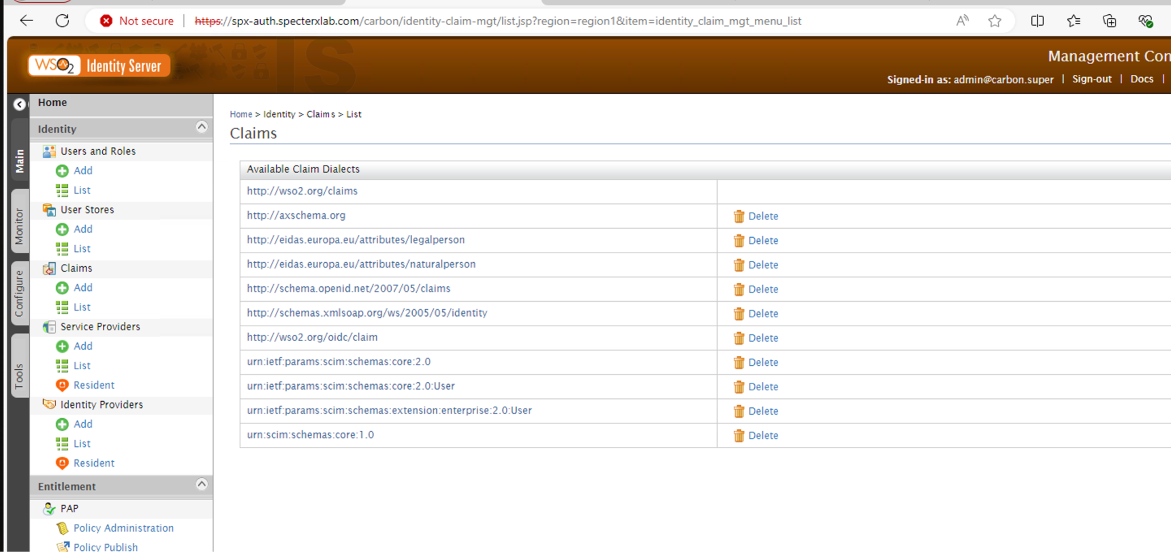
- Navigate to - Service Provider -> List -> Web Client. Click “Edit” the fill/validate the following configurations:
  - Service Provider Name: web-client
  - Description: SpecterX Web Application
  - Access URL: https://specterx.<customer-domain>
  - Configure “Claim Configuration” and “Role Mapping” to match the configurations as follows:
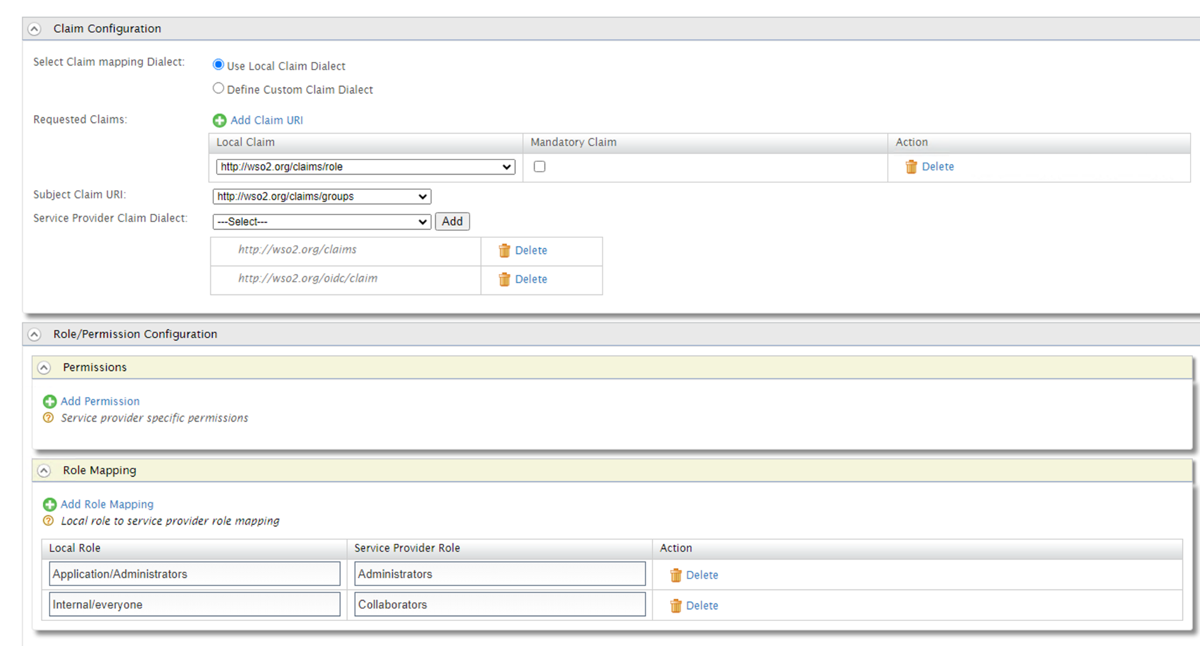
  - Open “Inbound Authentication Configuration” and validate/configure “OAuth/OpenID Connect Configuration” as follow:
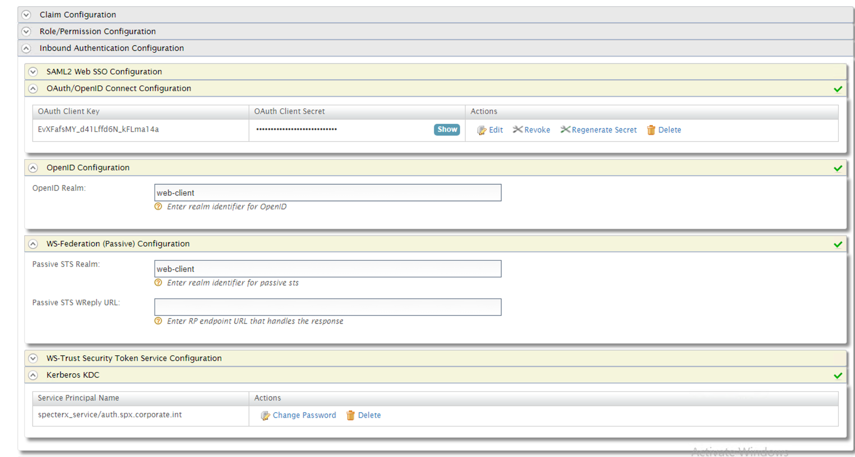
  - Copy the OAuth Client Key and OAuth Client Secret. These need to be configured in our web client config.
  - Inside “OAuth/OpenID Connect Configuration”, click Edit and configure the “Application Settings” to match as follows:
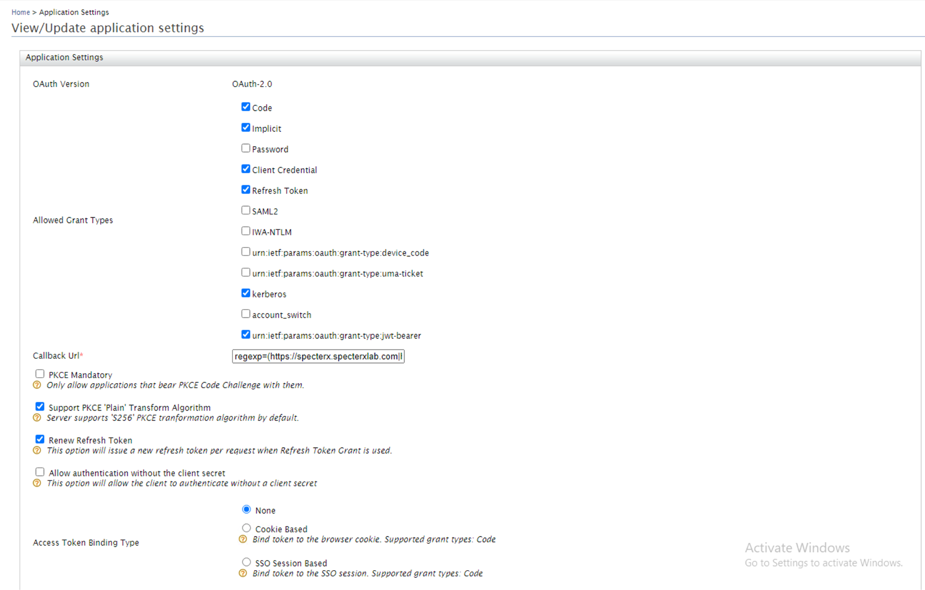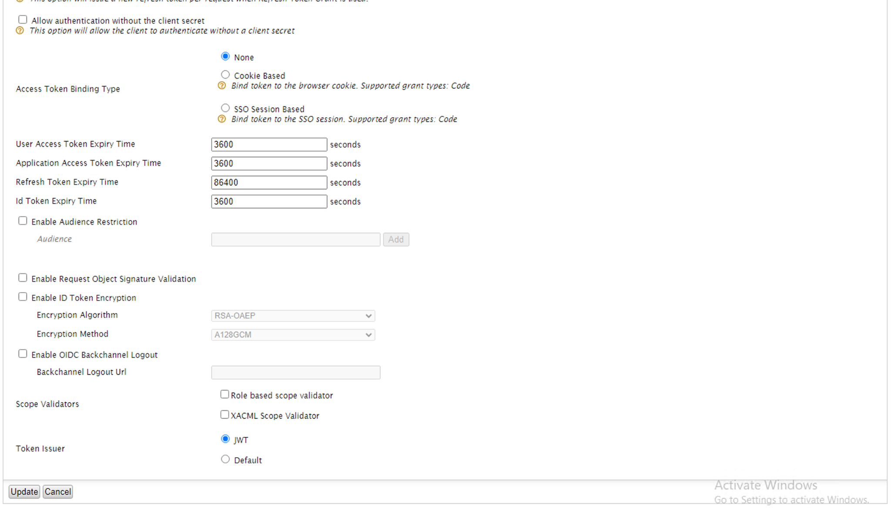
  - Complete the “OpenID Configuration”.
Note: No need to set the following. It is ok to leave any values you find there as they are:
- WS-Trust Security Token Service Configuration
- Kerberos KDC
  - Open ״Local & Outbound Authentication Configuration”
  - Uncheck “Enable Authorization”
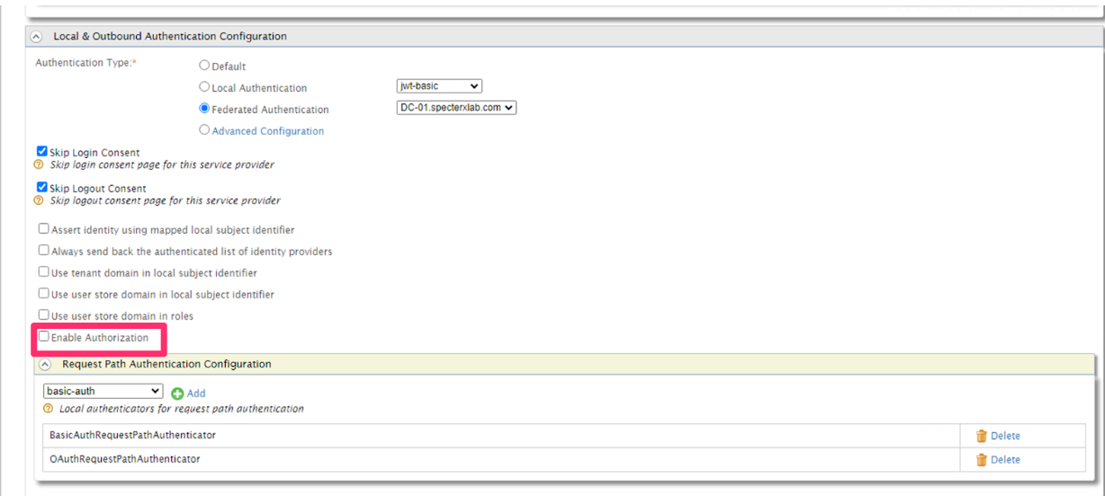
- From the leftside menu, under “Identity Providers” click “Add”.
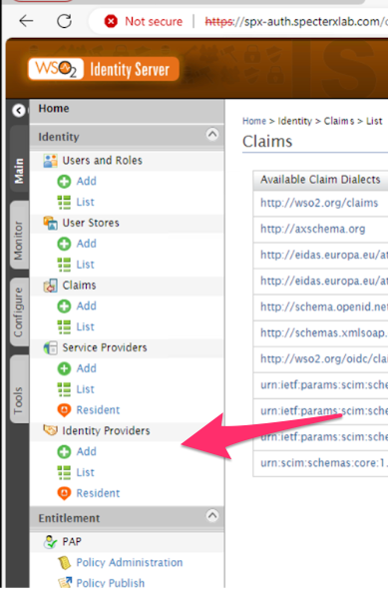
- Setup “Basic Information”.
  - Set Identity Provider Name: Enter the organization’s Identity Provider Name (usually the DNS name of the Active Directory)
  - Set Alias: https://spx-auth.<customer_domain>/oauth2/token
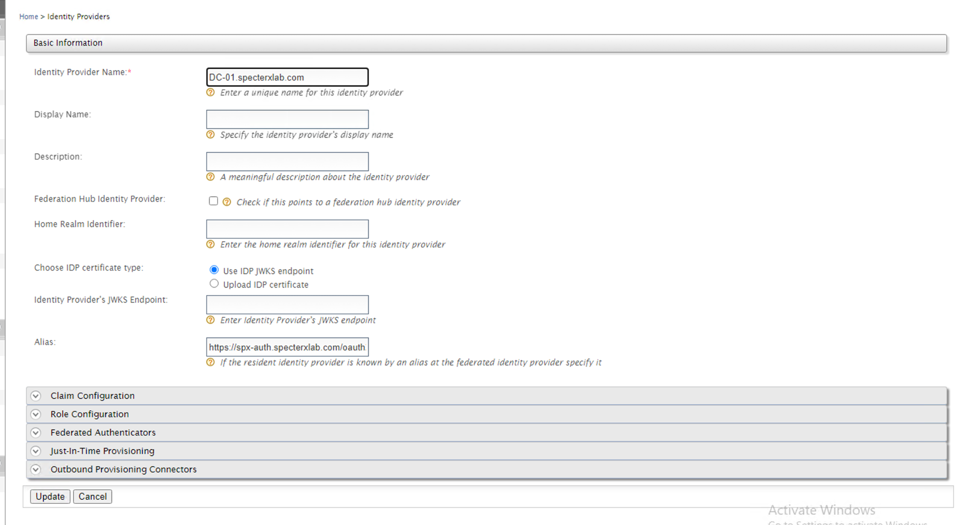
  - Open “Federated Authenticators” and under it open “IWA Kerberos Configuration”. Configure the “Service Principal Name” and “Service Principal Password” as it was created in the Active Directory. Should look similar to this:
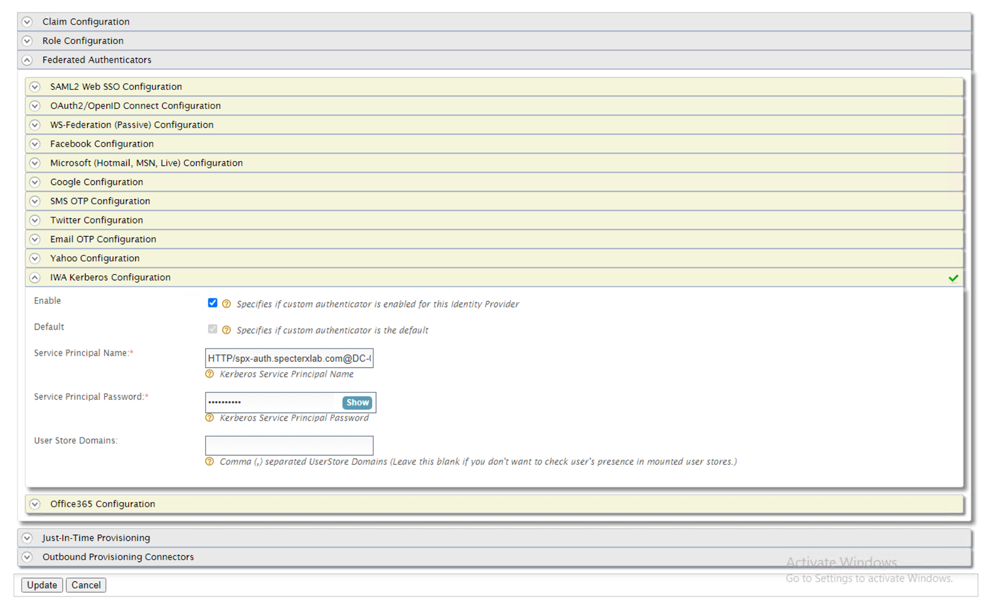
  - Under “Federated Authenticators” open “Just-in-Time” and configure it as follows:
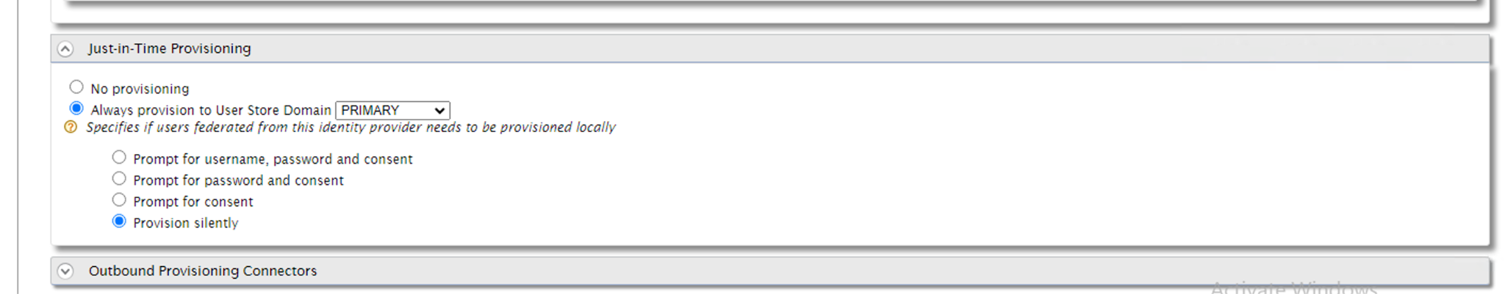
- Click “Register” / “Update”
- From the leftside menu, also under “Identity Providers” click “Resident”
  - Set Home Realm Identifier: spx-auth.<domain-name>
  - Missing: SAML2 Web SSO Configuration -> Identity Provider Entity ID -> spx-auth.
  - Configure the “Inbound Authentication Configuration” as follows:
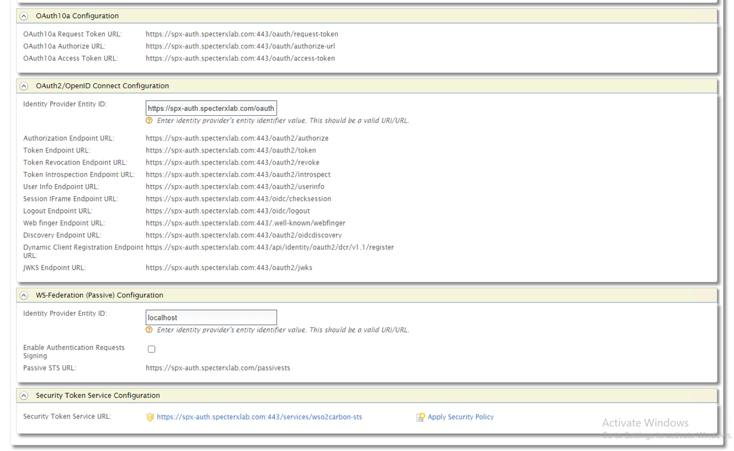

6) Setup WSO Backups
This step schedules a daily backup of WSO2 Identity Server using cron, the Linux job scheduler. We edit the crontab to add a job that runs the backup script every day at 05:35 AM. This ensures automatic backups without manual intervention.
- Edit the Crontab jobs.
Run `crontab -e`
- If asked which editor to use, choose Nano (usually the first one on the list)
- Set WSO2is to backup. Add the following line to the cron configuration in front of you.
Here is what you need to type:
35 5 * * * /op/specterx/scripts/wso2is_backup_restore.sh backup-daily 2>&1 | /usr/bin/logger -t BACKUP
- Save and close the file by clicking CTRL+X and choosing ‘Y’ to save.
- Validate new entry in Crontab.
Run `crontab -l`
You should see the line just entered printed to the console.

Sanity Checks
Ensure successful login to the SpecterX Web Platform (SSO)

Troubleshooting

WSO Web Console doesn’t open or doesn’t load properly
- Check routing configurations in Kong.
- Restart Kong.
- Delete WSO’s *.toml file. This will reset all WSO configurations back to default.

Definition of Done
All tasks have been completed without error, and users can seamlessly log into the SpecterX Web Platform through the configured WSO2is Identity provider connected to the customer's Active Directory.

Step 6: Storage Connector Service Configuration

Objective
To set up and validate the connection between the storage connector service and the customer's shared storage on a Linux machine.

1) Update the Storage Connector Credentials

Tasks
- The storage-connector credentials are saved in the storage-connector container under:
/etc/smbcredentials
- Edit this file and update the credentials the ones provisioned by the customer.

2) Mount the customer's shared storage to the Linux machine.
- Set the mount in ‘/etc/fstab’ using mount -a
- Validate successful connectivity to the customer's shared storage.
- Restart the services
- Validate the fstab configuration persistence after a restart.
- Assess the storage size to ensure it's unlimited.

Sanity Checks
- Copy a file to mounted shared storage.
- Check to verify that the service can successfully read/write test files.
- Upload the said file via SpecterX Web Platform
- Download the file via SpecterX Web Platform

Definition of Done
The storage connector service is fully configured, ensuring seamless interaction with the customer's shared storage from the Linux machine. Furthermore, files can be effortlessly uploaded/downloaded to/from the SpecterX Web Platform, evidencing successful configuration and connection.

Step 7: Mail Protection Service (MPS) Configuration

Objective
To integrate the Mail Protection Service (MPS) with the customer's mail flow and ensure efficient functioning of the Outlook add-in.

Tasks
- Connect the MPS service to the customer's mail flow.
- Install the Outlook add-in on a test workstation.
- Configure the MPS for both inbound and outbound mail relay settings.
- Add Outlook Add-in to Organization’s Endpoint Management SystemsDistribution Systems

Sanity checks
Test by sending a protected email and validate it is correctly intercepted and protected.

Definition of done
An email is successfully sent using the SpecterX Outlook add-in, facilitated by the configured Mail Protection Service.

Integration With Third-Party Systems
In this step, we’ll integrate SpecterX to other organizational systems, such as DLP, CDR, SIEM, etc.

Acceptance Tests

Scenario 1 - Two-Factor-Authentication

Data Owner (domain user)
- Opens Outlook and composes a new email.
- Attach a file using SpecterX’s ‘Attach Secured File’ button.
- Add *external recipient* to the ‘To’ field.
- Give the file the predefined ‘2FA’ policy.
  - Complete the phone number information for the external user in the section to the right - if needed.
- Toggle the switch to ‘protect the email body’
- Add a subject and some text to the email.
- Send the email.

External Recipient
- Find the email with the shared file and open it.
- Complete the simple 2FA OTP authentication flow.
- Access the file using one of the access methods (See Appendix C - Recipient Experience).

Data Owner (domain user)
- Data owner receives email notifications for each file interaction (open, download).
- Go to the Audit pane of the SpecterX portal to review the file interactions.

Scenario 2 - Supported File Types and Sizes

Data Owner (domain user)
- Opens Outlook and composes a new email.
- Attach a file using SpecterX’s ‘Attach Secured File’ button, and upload any file type in any size.
- Add *external recipient* to the ‘To’ field.
- You can keep the ‘default’ policy or choose to change it.
- Add a subject and some text to the email.
- Send the email.

Note-1: SpecterX platform supports up to 15Gb, since SpecterX is integrated with the customer’s email flow, it is required to allow the same limitation across the mail flow platforms (DLP, Mail Server).

Note-2: SpecterX API and Web UI allow support file shares for up to 15Gb.

External Recipient
- Find the email with the shared file and open it.
- Complete the simple OTP authentication flow (if needed).
- Access the file using one of the access methods (See Appendix C - Recipient Experience).

Scenario 3 - Sharing using SpecterX Mail Protection Service

Data Owner (domain user)
- Open Outlook and compose a new email, and attach a file.
- Send the mail to
  - Internal recipient (domain user)
  - External recipient

Note-1: SpecterX platform will be configured with a predefined policy (Default) which will protect any attached file and email body sent to external recipients and share it securely using SpecterX. Internal users will receive the attached file without any protection.

Internal User
- Open his mailbox to Find the file email with the shared attachment and verify the file is not protected by SpecterX.

External Recipient
- Find the email with the shared file and open it.
- Complete the simple OTP authentication flow (if needed).
- Access the file using one of the access methods (See Appendix C - Recipient Experience).

Scenario 4 - Data Leak Prevention (DLP) Integration

Data Owner (domain user)
- Opens Outlook and composes a new email.
- Attach a file using SpecterX’s ‘Attach Secured File’ button, choose a file that should be blocked by the organization’s DLP platform.
- Add *external recipient* to the ‘To’ field.
- You can keep the ‘default’ policy or choose to change it.
- Add a subject and some text to the email.
- Send the email.

Note-1: SpecterX platform Integrates into the organization’s DLP for the files to be scanned before shared with external parties.

- Data owner will receive an email notification mentioning the file sharing was blocked by the organization’s DLP.

Security Engineer
- Unquarantines the email and allows it to be shared.

External Recipient
- Find the email with the shared file and open it.
- Complete the simple OTP authentication flow (if needed).
- Access the file using one of the access methods (See Appendix C - Recipient Experience).

Troubleshooting
- Getting a response of “Header SpecterXUser is required”
  - Check Systemconfig.yml for “tenant_domain” configuration

Going to Production

7.1 Defining and Provisioning SpecterX Policies

7.2 Support Team Training

7.3 User Onboarding

Appendix 1 - LAN Segment Prerequisites

3.1. VM Provisioning and Specs
SpecterX’s system is composed of 2 instance types:
- Intranet VM - In charge of running and maintaining the core SpecterX services, such as authentication, connection to on-prem storage, connection to mail servers, etc...
- (optional) Edge VM - Performs the duty of the application request router to the Internet as well as a gateway that facilitates shipping of resource consumption metrics and service health indicators to SpecterX.

NOTE RAM and CPU resource consumption may vary according to usage in your organization. SpecterX personnel will proactively notify the technical contact in the case that additional resources are needed to comply with SLA requirements.

3.1.1. Intranet VM (2 instances) Resources
CPU cores 4 cores (>=2.2Ghz)
RAM 16 GB
Disk space 80GB
Network interface 1Gbps

SpecterX will provide a pre-baked OVF image to deploy on this VM.

3.1.2. Network settings (LAN)
Please allocate and fill in the following network details:

Address purpose | IP (Mask)
LAN Load Balancer VIP for SpecterX
SpecterX Intranet VM instance #1
SpecterX Intranet VM instance #2

Please fill in these network details for the following LAN resources:
Org LAN Netmask
Org LAN Gateway
Org LAN DNS servers (if there is more than one DNS server, please list all of them)
Org LAN NTP server
Org LAN Outgoing mail relay

3.1.3. Required DNS/LB configuration
Please create the following DNS records and load balancer target groups:
DNS FQDN | LB group members | LB Port/Protocol
specterx.company.domain -> LAN LB VIP | Intranet VM1  Intranet VM2 | 443/TCP
spx-api.company.domain -> LAN LB VIP | Intranet VM1  Intranet VM2 | 443/TCP
spx-auth.company.domain -> LAN LB VIP | Intranet VM1  Intranet VM2 | 443/TCP
spx-mps.company.domain -> LAN LB VIP | Intranet VM1  Intranet VM2 | 25/SMTP
DNS records for resources in the DMZ network segment
spx-edgeapi.company.domain -> DMZ LB VIP | Edge VM1  Edge VM2 | 443/TCP

3.1.4. Required Firewall rules
Please open the following rules in your organization’s Firewalls:

# | Reason | Source | Destination | Port
 | Allow Outlook Addin on user workstations to access the SpecterX intranet services | User workstations / Citrix | spx-auth.company.domain  spx-api.company.domain  spx-edgeapi.company.domain  specterx.company.domain | TCP 443
 | Allow communications between our intranet services | Intranet VMs IPs (as allocated in section 2.1.2 of this document) | spx-auth.company.domain  spx-api.company.domain  spx-edgeapi.company.domain  specterx.company.domain | TCP 443
 | Allow communications between our intranet services and the DNS servers | Intranet VMs IPs (as allocated in section 2.1.2 of this document) | <LAN DNS resolvers> | TCP/UDP 53
 | In case the customer wants to install Splunk agent, this will rule allow communications between our intranet services and Splunk | Intranet VMs IPs (as allocated in section 2.1.2 of this document) | <Splunk server address> | UDP 514
 | Allow communications between our intranet services and the organization’s DLP service, for example Forcepoint | <DLP address> | spx-mps.company.domain | TCP 25
 | Allow communications between our intranet services and the dedicated NAS storage | Intranet VMs IPs (as allocated in section 2.1.2 of this document) | <NAS storage> | TCP 445/  2049+111
 | Sending email notifications to recipients and file owners | Intranet VMs IPs (as allocated in section 2.1.2 of this document) | <LAN SMTP mail relay> | TCP 25
 | Synchronizing server clocks to match log times with the customer’s systems | Intranet VMs IPs (as allocated in section 2.1.2 of this document) | <LAN NTP address> | UDP 123
 | Authenticating users inside the customer’s domain | Intranet VMs IPs (as allocated in section 2.1.2 of this document) | <AD/Domain address> | TCP 88

3.1.5. Additional Firewall Rules - Required for Maintenance
This rule is related to ​​section 3.4. Testing and Maintenance Environment for SpecterX and this would greatly speed up delivery of new features as well as substantially decrease risks when rolling out new versions to end-users. More information in section 3.4.

#1 | Allow communication from testing workstation to access the SpecterX intranet services directly | Intranet VMs IPs (as allocated in section 2.1.2 of this document) | SpecterX Intranet VM instance #1  SpecterX Intranet VM instance #2 | TCP 443 + SSH 22

3.2. SSL Certificates
SpecterX solution relies on SSL/TLS to provide end-to-end encryption of data in motion and ensure server identity. It is up to the customer to provide the appropriate SSL certificate(s).

Important: SpecterX requires that the certificate be provisioned by a commonly trusted authority (or signed by a corporate CA). Any level of authority is acceptable as long as the CA chain is provided.

Certificate scope | Common Name | Subject Alt Names
Intranet SSL certificate | specterx.company.domain | spx-api.company.domain  spx-edgeapi.company.domain  spx-auth.company.domain  spx-mps.company.domain

3.3. Authentication & SSO
Our solution supports the following authentication & authorization methods:
- SpecterX cloud IdP with either in-house or federated user pool management
- SpecterX on-prem IdP with federated authentication against Active Directory (Kerberos)
- SpecterX embedded IdP with a self-contained user pool

As authentication and identity management solutions tend to be highly specific - please contact us to discuss the preferred solution in detail.

3.4. Shared storage access
SpecterX’s solution relies on customer-provided shared storage volume. This volume is used for the following purposes:
- Storing the files shared using SpecterX
- Holding encrypted backups of SpecterX system state

Property | Value
Storage access protocol | NFS/SMB
Protocol port(s) if custom
NAS address
NAS share path
NAS mapped UID (if applicable)
Disk space quota
Disk I/O ops/sec quota

3.5. Outgoing mail relay access
To protect outgoing emails in a centralized manner, rather than on the endpoint themselves, SpecterX’s solution requires the following information and setup to enable its Mail Protection Service.

Property | Value
Outgoing mail protocol | SMTP/SMTPS
Outgoing protocol port(s)
Corporate MTA/mail relay address
MTA/mail relay credentials (if required)

Important: Customer’s mail relay has to be configured to allow relaying email from both of the Intranet VM LAN addresses.

Appendix 2 - DMZ Segment Prerequisites

2.1. VM Provisioning and Specs
SpecterX’s system is composed of 2 instance types:
- Intranet VM - In charge of running and maintaining the core SpecterX services, such as authentication, connection to on-prem storage, connection to mail servers, etc...
- Edge VM - Performs the duty of the application request router to the Internet as well as a gateway that facilitates shipping of resource consumption metrics and service health indicators to SpecterX.

These instances are required for situations when the customer operates a network with separate LAN and DMZ segments. Edge VMs perform the role of API Gateway isolating the sensitive SpecterX components that touch customer’s data from the rest of SpecterX SaaS/cloud infrastructure.

2.1.1. Edge VM (2 instances) Resources
CPU cores 2 cores (>=2.2Ghz)
RAM 8 GB
Disk space 50GB
Disk Image SpecterX-provided pre-baked OVF
Network interface 1Gbps

2.1.2. Network Settings
Please allocate and fill in the following network details:

Address purpose | IP (Mask)
DMZ Load Balancer VIP for SpecterX
SpecterX Edge VM instance #1
SpecterX Edge VM instance #2

Please fill in these network details for the following DMZ resources:

Org DMZ Netmask
Org DMZ Gateway
Org DMZ DNS servers (if there is more than one DNS server, please list all of them)
Org DMZ NTP server

2.1.3. Required DNS/LB configuration
Please create the following DNS records and load balancer target groups:

DNS FQDN | LB group members | LB Port/Protocol
spx-edgeapi.company.domain -> DMZ LB VIP | Edge VM1  Edge VM2 | 443/TCP

2.1.4. Required Firewall rules
Please open the following rules in your organization’s Firewalls:

# | Reason | Source | Destination | Port
 | Allow communications between our Edge services and Splunk | Edge VMs IPs  (as allocated in section 2.1.2 of this document) | <DMZ Splunk server address> | SPLUNK
 | Synchronizing server clocks to match log times with company systems | Edge VMs IPs  (as allocated in section 2.1.2 of this document) | <DMZ NTP address> | UDP 123
 | API calls from the Intranet servers to the SpecterX cloud app | Intranet VM IPs  (notice that these are the LAN VM IPs, not Edge) | spx-edgeapi.company.domain | TCP 443

2.2. SSL Certificates
The same certificate can be used for Edge server as on the Intranet instances (as described in the LAN deployment requirements). However, it is possible to use a dedicated certificate issued to a single Common Name: spx-edgeapi.company.domain

Appendix 3 - Useful Docker Commands

Access a Running Container's Shell
sudo docker exec -it <container_name> /bin/bash
- Purpose: Opens an interactive bash shell inside the running container.
- Example:
sudo docker exec -it mail-protection /bin/bash


Copy Files from Container to Host
docker cp <container_name>:<path/to/file/in/container> <path/on/host>
- Purpose: Copies files from a container to the host machine for editing or backup.
- Example:
docker cp mail-protection:/app/src/helpers/emaul_handlers.py .


Copy Files from Host to Container
docker cp <path/on/host> <container_name>:<path/to/file/in/container>
- Purpose: Copies files from the host machine to the container for updates or deployment.
- Example:
docker cp file mail-protection:/path/to/


Edit Files Inside the Host
- Use a text editor like vim to modify files extracted from the container:
vim file
  - Press i to enter insert mode for editing.
  - After making changes, save and exit:
:wq!


Restart a Docker Container
docker restart <container_name>
- Purpose: Restarts a container to apply changes or reset the application.
- Example:
docker restart mail-protection


Restart All Docker Containers
docker restart $(docker ps -a -q)
- Purpose: Restarts all containers to apply changes or refresh the entire gateway for troubleshooting purposes or any other reason.

Example Workflow
- Access the container's shell:
sudo docker exec -it mail-protection /bin/bash
- Copy a file from the container to the host:
docker cp mail-protection:/path/to/file .
- Edit the file using vim:
vim file
- Save and exit vim:
:wq!
- Copy the modified file back to the container:
docker cp file mail-protection:/path/to/
- Restart the container to apply changes:
docker restart mail-protection


Appendinx 4 - Kong YAML File Examle

